How to add parameters and write message

1. Create pipeline 1, add parameters name and address

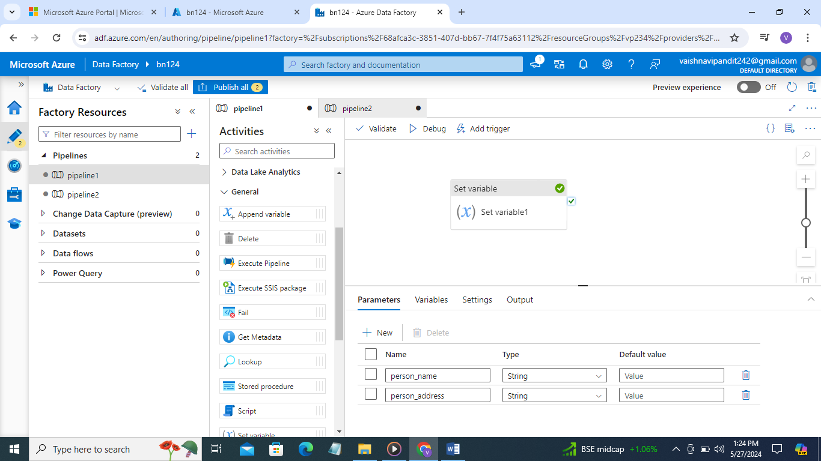

1. Now create message variable

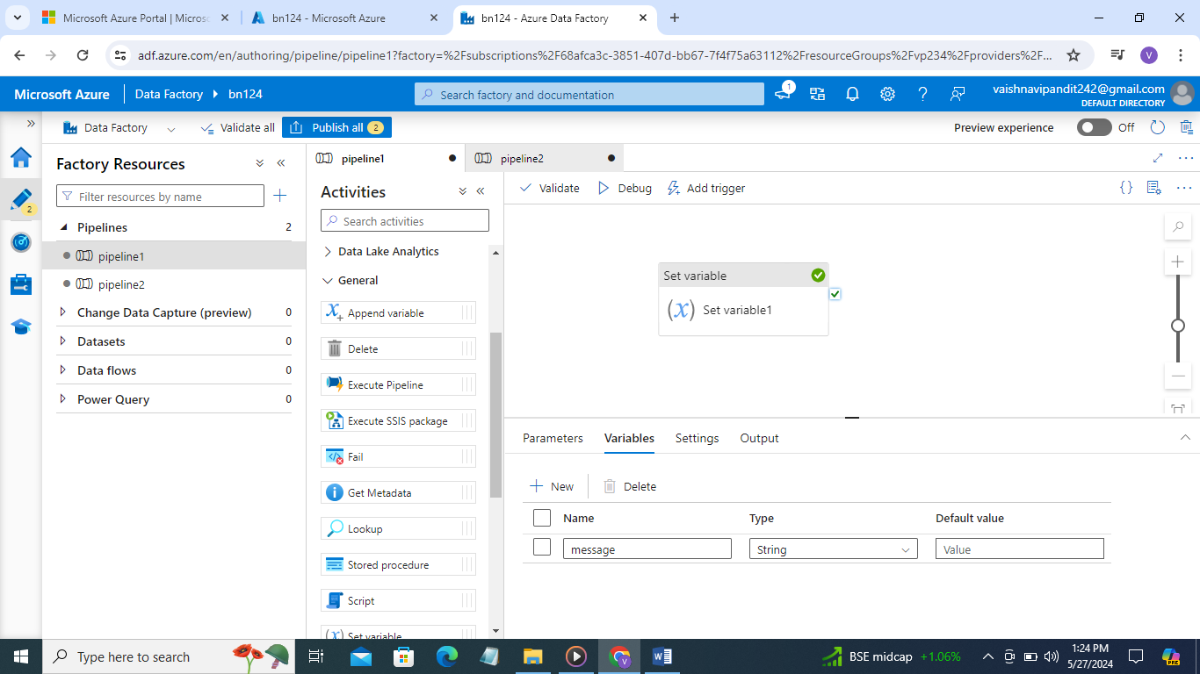

1. Now create set variable activity for message variable add value function concat person name is ,parameter name same for address

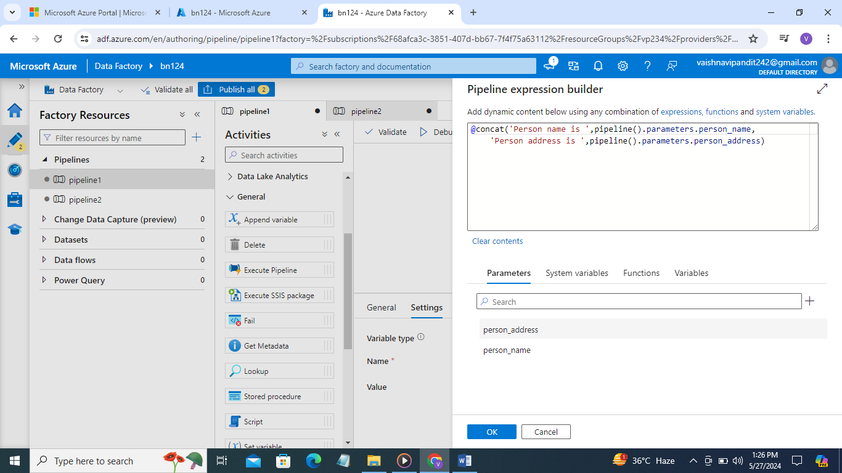

1. Now create one more pipeline drag and drop execute pipeline from general

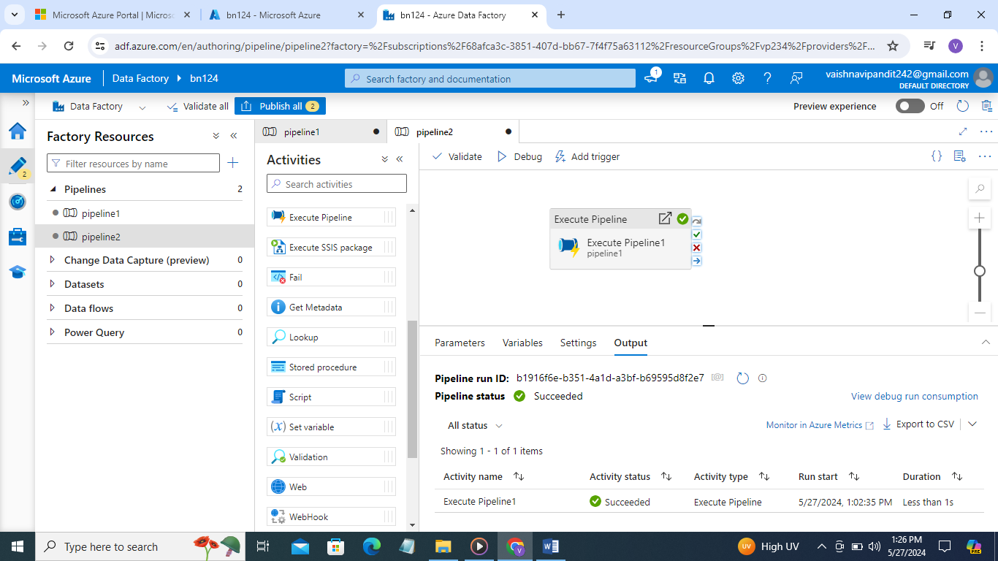

1. Now go to settings add invoked pipeline pipeline1

And add parameter values

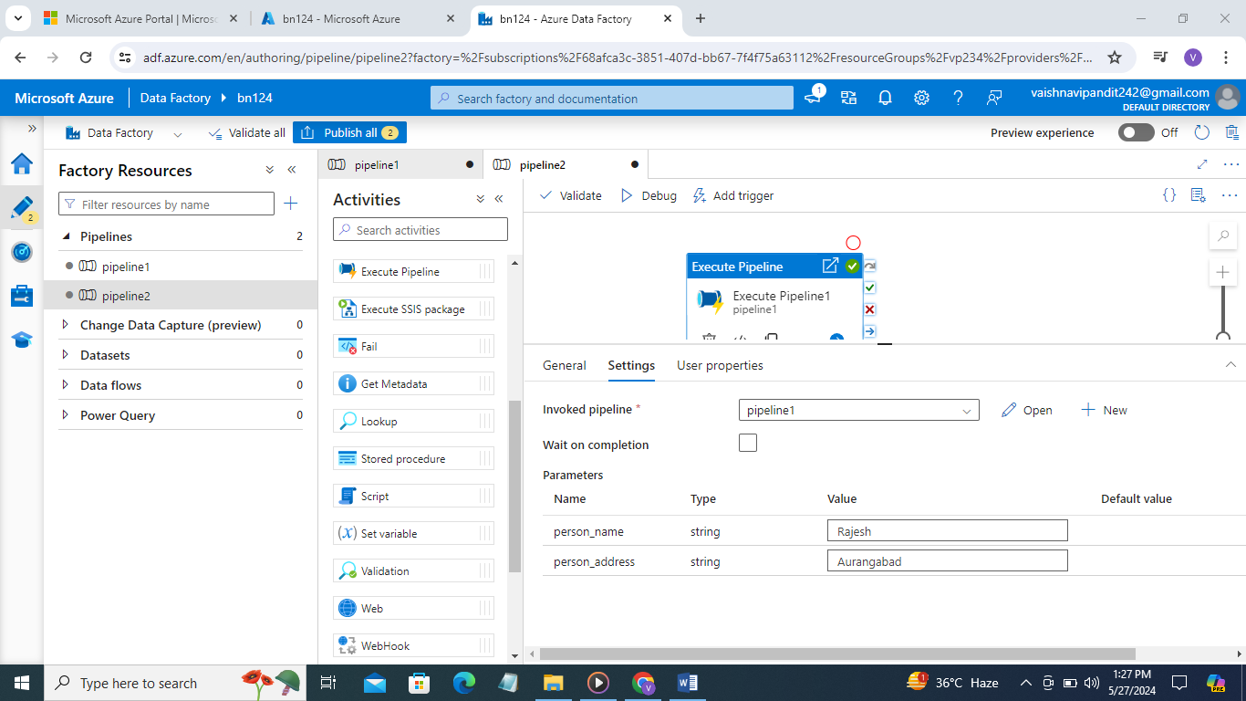

1. Now debug go to pipeline 2 output

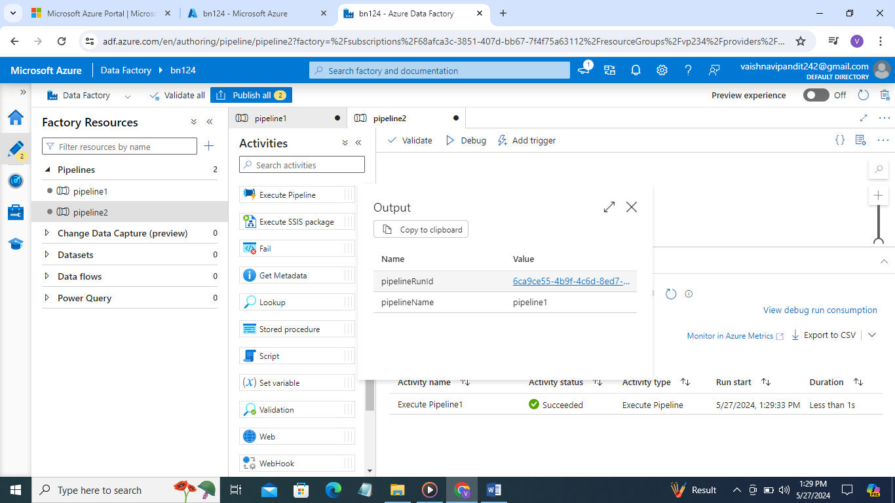

1. You will find link there in pipelinerunid go to link you will find pipeline 1 output

